Adjusting your headlights after Installation Instruction

Although installation instructions may be provided, it is essential that buyers understand RedLine LumTronix Inc vehicle lighting products are vehicle related and require installation and vehicle knowledge. Installation skill and experience varies so it is recommended the RedLine LumTronix Inc vehicle lighting products are installed professionally. RedLine LumTronix Inc are not responsible for any damage incurred by the improper installation of any products installed professionally or unprofessionally.

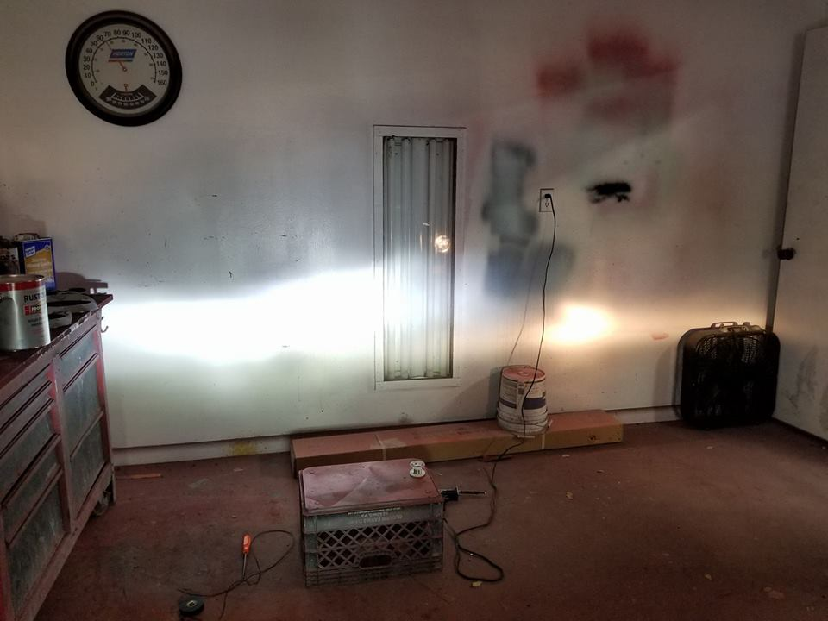

When installing our headlights, you must know they will not be focused the same as the headlights you removed from your vehicle. It is essential you adjust your headlights horizontally and vertically anytime you replace your headlights. Use the below link to see how to adjust your headlights correctly. You will need a space to back up your vehicle of 25 feet from a garage, fence, or wall. A tape measure, level, and painters’ tape.

If you have a two-headlight system, your low beam and high beam are in each headlight, so you only must adjust both headlights one time.

If you have a four-headlight system you have two headlights usually the outer two headlights or the lower two headlights, if your headlights are position on top of each other vertically such as those found on some Ford galaxy models, are your low beam headlights. You will need to adjust these headlights first. The other two remaining headlights are high beam headlights. You will have to repeat the same procedure to adjust the high beam headlights.

Copy the below link into your browser and view the video.

https://www.hagerty.com/media/videos/how-to-adjust-sealed-beam-headlights

