Headlight Bucket Multi-Color Extension Cable CE-010
Instruction

Although installation instructions may be provided, it is essential that buyers understand RedLine LumTronix Inc vehicle lighting products are vehicle related and require installation and vehicle knowledge. Installation skill and experience varies so it is recommended the RedLine LumTronix Inc vehicle lighting products are installed professionally. RedLine LumTronix Inc are not responsible for any damage incurred by the improper installation of any products installed professionally or unprofessionally.

Always bench test this product before installation, so you may discover any problems before you spend the time to fully install this product.

This harness allows the installer to connect to a multi-color headlight within a headlight bucket to the control unit harness.

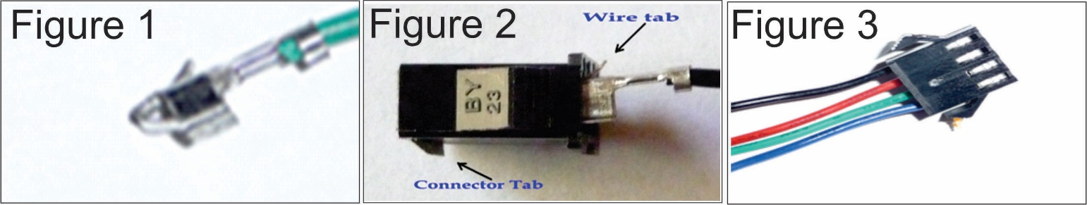

- Take each of the extensions wires and pull them through from the bottom of the headlight bucket mount up into the headlight shell. You may use a small bread tie or a small fish to pull each wire through. If you look at each wire closely you will see a hoop (as seen in figure 1) on the end of each wire. Place the bread tie or fishhook into the hoop and pull each wire through the hollow headlight mount and conduit one wire at a time.

- Once each connector has been pulled through you will next need to place the connector back on. Before placing each wire into the connector make sure you place each wire into the connector as shown in figure 2. Looking at the connector from it’s side place each wire with the wire tab up and the connector tab down, push in each wire in the order specified in step 3 until you hear the wire snap into place. LOOK at step 3 before you snap each wire in place because it is not easy to pull the wire back out.

- With the connector slots faced up (as you see in figure 3) you will need to place each wire in order into the connector from left to right. Black, Red, Green Blue. Should look like figure 3 when finished.

