Installing H4 9003 Ceramic Connector Wiring Harness EH-003
Installation Instruction

Although installation instructions may be provided, it is essential that buyers understand RedLine Lumtronix Inc vehicle lighting products are vehicle related and require installation and vehicle knowledge. Installation skill and experience varies so it is recommended the RedlLine LumTronix Inc vehicle lighting products are installed professionally. RedLine LumTronix Inc are not responsible for any damage incurred by the improper installation of any products installed professionally or unprofessionally.

Always bench test this product before installation, so you may discover any problems before you spend the time to fully install this product.

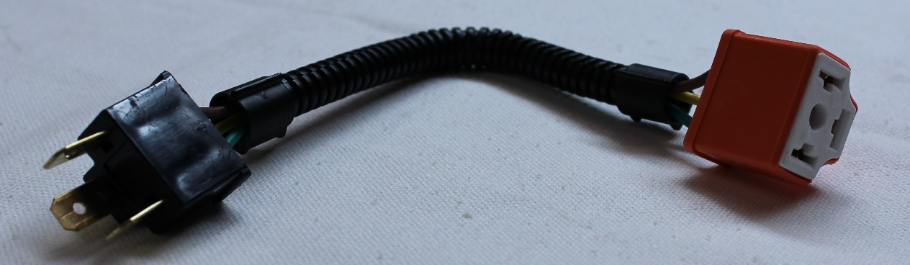

Purpose of this harness is to place it in between your vehicle harness and our headlight. H4 Halogen, Xenon and Plasma bulbs all produce high temperatures on the back side of the bulb. Some vehicle connectors were plastic and will melt if you do not use this harness. The ceramic tip of the harness absorbs the heat of the lamp protecting your original harness.

- Connect the ceramic tip of the harness to back of the three prongs of the headlight. NEVER leave a headlight hanging from the harness.

- Connect the three male prongs of the ceramic harness onto your vehicle harness headlight connector.

- Vehicles with 4 headlights; Each Headlight we sell is equipped with high and low beam bulb. When replacing your original high beams you may connect your high beam headlight connector on your OEM headlight harness directly to the two vertical prongs on the back of the bulb (not recommended, or use our H4 Ceramic Harness because the heat can damage your OEM headlight connector) or to the two vertical prongs on the H4 Ceramic Harness we provided. The horizontal prong not connected (either on the bulb or our harness) is the low beam prong which will not have any power and will not cause you any problems. If you use the provided H4 Ceramic Harness you may bend or cut the unused prong.

- RedLine LumTronix INC is not responsible for and damage that may be caused to your OEM headlight harness if you decide to not use this harness.

