Installing In-Cab Indicator for Multi-Color headlights CU-001
Installation Instruction

Although installation instructions may be provided, it is essential that buyers understand RedLine LumTronix Inc vehicle lighting products are vehicle related and require installation and vehicle knowledge. Installation skill and experience varies so it is recommended the RedLine LumTronix Inc vehicle lighting products are installed professionally. RedLine LumTronix Inc are not responsible for any damage incurred by the improper installation of any products installed professionally or unprofessionally.

Always bench test this product before installation, so you may discover any problems before you spend the time to fully install this product.

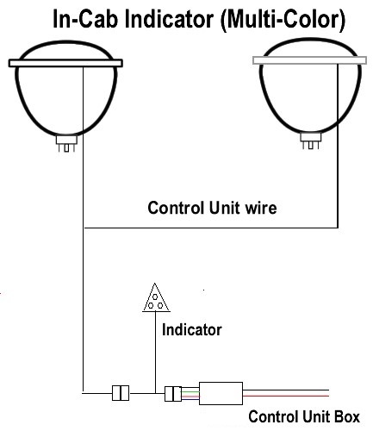
Part #: CU-001

This accessory is the perfect accessory to be insured of what color your headlights are on at all times. You don’t want to be pulled over by the police because you forgot and left your halo’s on red. We like to think of it as the traffic ticket saver.

- You can install this indicator anywhere along the multi-color harness. Most people place it in between the control unit box and the multi-color harness. It is made to be in line with a 36” wire to reach anywhere in your cab.

- The indicator can be bright as your headlight halo color so you may want to mount it under the dash, center console or ash tray. If you want to tone down the color output of the indicator using a piece of window tint. Just attach the widow tint to the indicator and wrap it around to the back and place a small drop of super glue for the window tint to be secure.

