Installing Retaining Ring Headlight Cushions
Installation Instruction

Although installation instructions may be provided, it is essential that buyers understand RedLine LumTronix Inc vehicle lighting products are vehicle related and require installation and vehicle knowledge. Installation skill and experience varies so it is recommended the RedLine LumTronix Inc vehicle lighting products are installed professionally. RedLine LumTronix Inc are not responsible for any damage incurred by the improper installation of any products installed professionally or unprofessionally.

Always bench test this product before installation, so you may discover any problems before you spend the time to fully install this product.

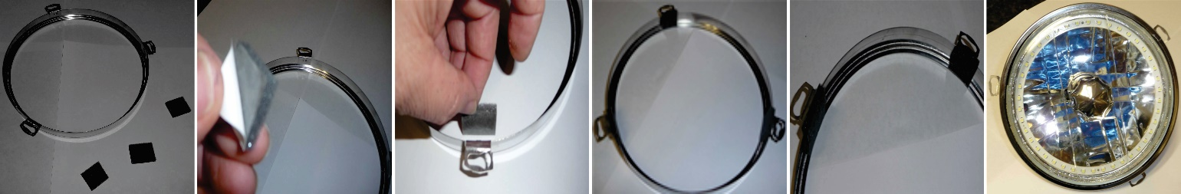

Place supplied headlight cushions (small square sponge foam) into the retaining ring.

- Placing the cushions is not a requirement but a suggestion to keep your bezel from cracking your headlight.

- Take the back off the cushion exposing the sticky part.

- Divide the inside of the retaining ring into thirds and place a cushion in each of those places. Fitment may be tight but cushioned

When reinstall the retaining rings but do not over tighten screws. OVER TIGHTNING HEADLIGHT BEZELS OR RETAINING RINGS MAY CAUSE HEADLIGHT GLASS TO CRACK under some driving conditions. Reinstall headlight. RedLine LumTronix INC is not responsible for any cracked glass after installment. If you do crack your lens you can have it replaced by RedLine LumTronix Inc for a fee, so you do not lose you investment.

