Installing Single Color Ignition Harness (EH-005)
Installation Instruction

Although installation instructions may be provided, it is essential that buyers understand RedLine LumTronix Inc vehicle lighting products are vehicle related and require installation and vehicle knowledge. Installation skill and experience varies so it is recommended the RedLine LumTronix Inc vehicle lighting products are installed professionally. RedLine LumTronix Inc are not responsible for any damage incurred by the improper installation of any products installed professionally or unprofessionally.

Always bench test this product before installation, so you may discover any problems before you spend the time to fully install this product.

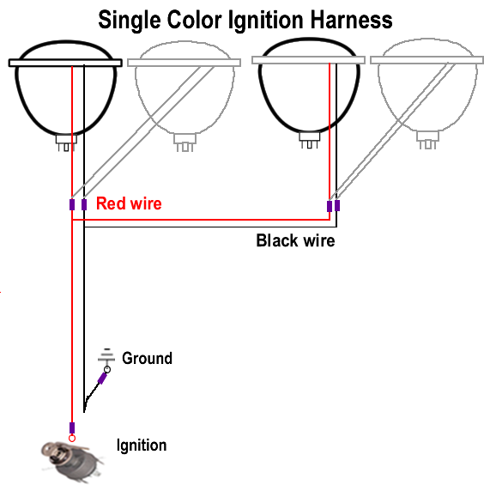
Item #: EH-005

This harness allows your headlights to stay on only when your ignition is on. Now they will see you before they pull out in front of you.
Installation:

- The waterproof connectors are quick disconnecting so if you must replace your headlight you simply disconnect it. Place both wires into the backside of each connector; connect the red for positive wire from the harness to the red wire coming from the headlight(s) and crimp the wire to stay in place. Connect the black for Negative wire from the harness to the black wire coming from the headlight and crimp the wire to stay in place. Do this step for all headlights. If you have four headlights, then you would place two red wires coming from headlights into the red wired connector on one side and the same for the black wire for the other connector.
- Route the wire with the two hoop connectors inside the cab and connect the red positive wire to your ignition and connect the black wire to your chassis.

