Installing 4 Lamp 2 Relay Headlight Power Upgrade EH-002
Installation Instructions

Although installation instructions may be provided, it is essential that buyers understand RedLine LumTronix Inc vehicle lighting products are vehicle related and require installation and vehicle knowledge. Installation skill and experience varies so it is recommended the RedLine LumTronix Inc vehicle lighting products are installed professionally. RedLine LumTronix Inc are not responsible for any damage incurred by the improper installation of any products installed professionally or unprofessionally.

Always bench test this product before installation, so you may discover any problems before you spend the time to fully install this product.

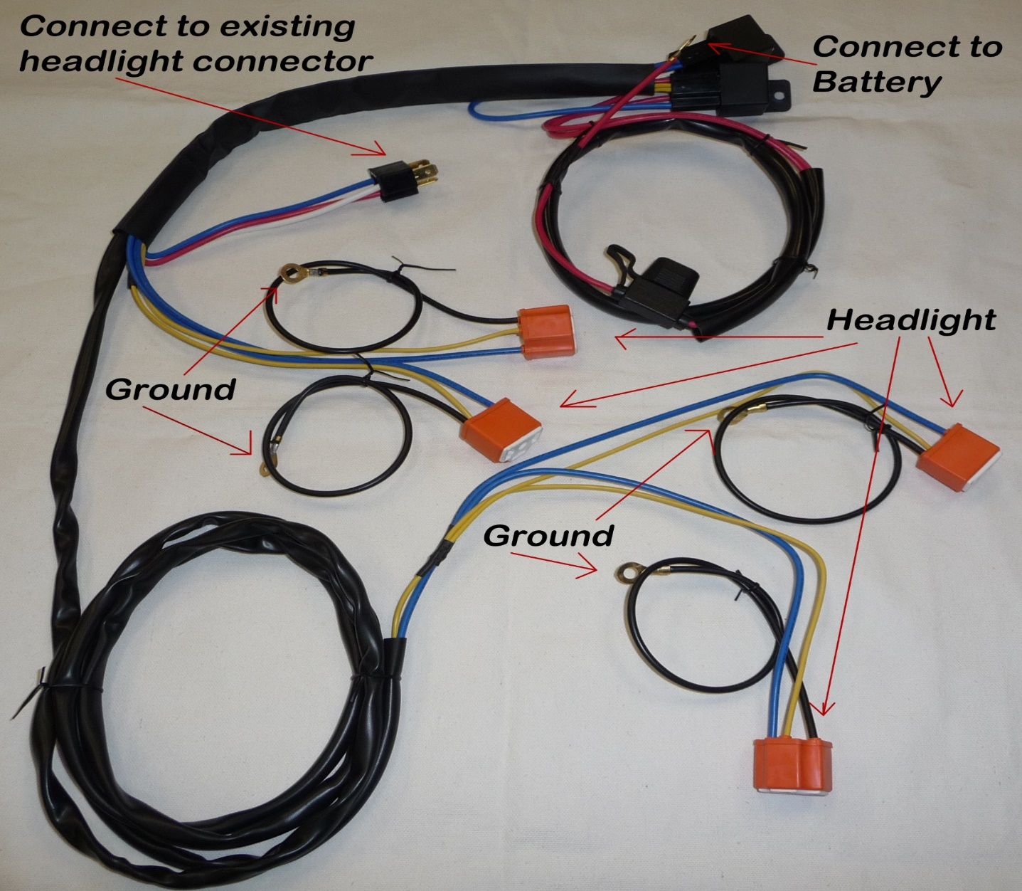

If your main beam is dim or blinking off/on, it is because your switch is overheating because it cannot effectively supply a constant supply of power to keep them on. Switches made back then were not made for the wattage necessary to for modern day incandescent bulbs. This harness will solve this problem. With our system you do not have to slice or dice your OEM harness, just Plug and Play our harness and it is ready to go. An added benefit to our harness is that it allows you to luminate all 4 low beam and all 4 high beams when you use our three prong headlights in the high beam headlight position. Your original OEM harness would only allow 2 low beam headlights to be luminated. It is now DOT legal to luminate all for Low beam headlights. A feature of this harness is that it is made with extra wire between the headlights so you may wire hide the harness.

- Connect three prong male connector into an existing headlight connector.

- Connect the attached hoop connector of each Black wires on the headlight connectors to a good ground connection to your chassis.

- Connect the Red wire with a hoop connector to a battery source.

- Your done, It is really that easy

- If you have a two-headlight system, we sell “2 Lamp 2 relay headlight upgrade harness” EH-001.

