Multi-Color Control Unit and Harness (CU-003, CU-004, CU-005) Installation Instruction

Although installation instructions may be provided, it is essential that buyers understand RedLine LumTronix Inc vehicle lighting products are vehicle related and require installation and vehicle knowledge. Installation skill and experience varies so it is recommended the RedLine LumTronix Inc vehicle lighting products are installed professionally. RedLine LumTronix Inc are not responsible for any damage incurred by the improper installation of any products installed professionally or unprofessionally.

Always bench test this product before installation, so you may discover any problems before you spend the time to fully install this product.

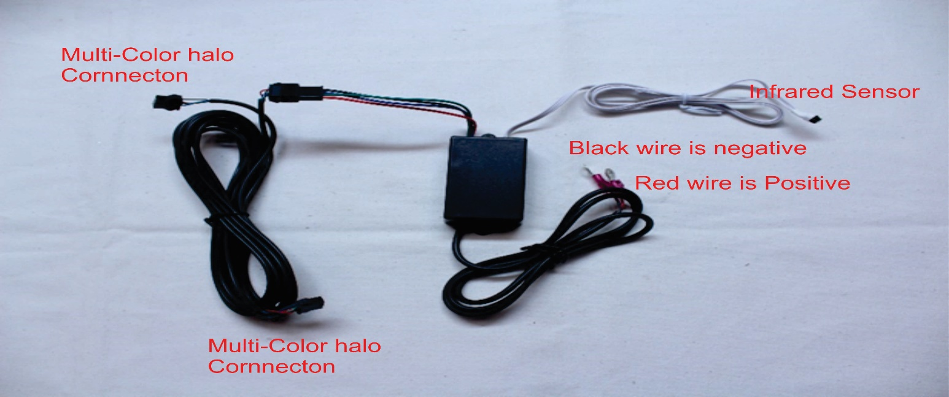

- Place the red wire on a positive battery source or to your ignition switch. Connect the black wire on a negative battery source or to a good chassis connection.

- Connect each headlight connector to the multi-color halo connector on the headlight.

- Place the Infrared sensor in a place where you can point the wireless remote at. You need to point in a line of sight for it to work. The brighter it is outside in the sun you might have to point closer to the sensor. A lot of people place the infrared sensor just inside the front windshield inside of the cabin of the car, this way they can point at the infrared sensor from inside of the car or outside of the car to change colors anytime they want.

- The multi-color controller (Black Box) is not waterproof, so you will need to place it in a safe place or waterproof it somehow.

