No Halo Headlights Installation Instruction

Although installation instructions may be provided, it is essential that buyers understand RedLine LumTronix Inc vehicle lighting products are vehicle related and require installation and vehicle knowledge. Installation skill and experience varies so it is recommended the RedLine LumTronix Inc vehicle lighting products are installed professionally. RedLine LumTronix Inc are not responsible for any damage incurred by the improper installation of any products installed professionally or unprofessionally.

Always bench test this product before installation, so you may discover any problems before you spend the time to fully install this product.

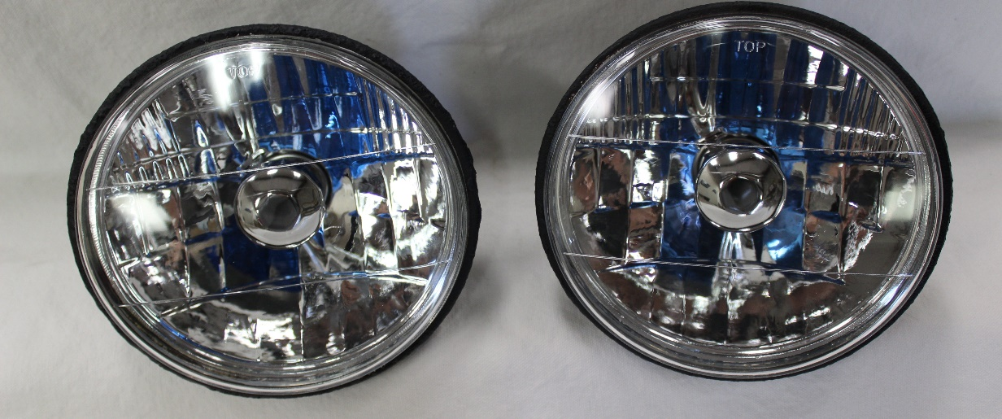

- Turn off your car by taking your keys out of the ignition.

- Remove any headlight bezels and retaining rings.

- Pull the headlight away from the car and disconnect the headlight wire harness connector to completely remove the headlight.

- Place your new No Halo headlights near the light bucket, connect the supplied H4 Ceramic Harness to your headlights and then to your OEM headlight wire harness. The H4 Ceramic harness is supplied to keep the heat from the bulb from melting your OEM headlight connector. NEVER leave headlight hanging from harness.

- Vehicles with 4 headlights; Each Headlight we sell is equipped with high and low beam bulb. When replacing your original high beams you may connect your high beam headlight connector on your OEM headlight harness directly to the two vertical prongs on the back of the bulb (not recommended, or use our H4 Ceramic Harness because the heat can damage your OEM headlight connector) or to the two vertical prongs on the H4 Ceramic Harness we provided. The horizontal prong not connected (either on the bulb or our harness) is the low beam prong which will not have any power and will not cause you any problems. If you use the provided H4 Ceramic Harness you may bend or cut the unused prong.

- Replace headlight into light bucket. Place supplied headlight cushions (small square sponge foam) into the retaining ring. See “Installing Retaining Ring Headlight Cushions Installation Instructions” to learn how to install. When reinstall the retaining rings but do not over tighten screws. OVER TIGHTNING HEADLIGHT BEZELS OR RETAINING RINGS MAY CAUSE HEADLIGHT GLASS TO CRACK under some driving conditions. Reinstall headlight. RedLine LumTronix INC is not responsible for any cracked glass after installment. If you do crack your lens you can have it replaced by RedLine LumTronix Inc for a fee, so you don’t lose you investment.

- You must adjust your headlight beam to make sure you see the road and not blind any oncoming drivers. THIS STEP MUST ALWAYS BE COMPLETED because our focus beam is different than any other headlight. Use “Adjusting your headlights after Installation” instructions to adjust your headlights.

- If your main beam is dim or blinking off/on, it is because your switch is overheating because it cannot effectively supply a constant supply of power to keep them on. Switches made back then were not made for the wattage necessary to for modern day incandescent bulbs. To solve this problem, we sell a upgrade harness with relays that will resolve this or you can purchase higher current headlight switch made for your vehicle which can handle Halogen/Xenon bulbs. Our upgrade harness “2 Lamp 2 relay headlight upgrade harness” EH-001 is for two headlight systems or “4 Lamp 2 relay headlight upgrade harness” EH-002 is for four headlight systems.

