Replacing the Incandescent Bulb Installation Instructions

Although installation instructions may be provided, it is essential that buyers understand RedLine LumTronix Inc vehicle lighting products are vehicle related and require installation and vehicle knowledge. Installation skill and experience varies so it is recommended the RedLine LumTronix Inc vehicle lighting products are installed professionally. RedLine LumTronix Inc are not responsible for any damage incurred by the improper installation of any products installed professionally or unprofessionally.

Always bench test this product before installation, so you may discover any problems before you spend the time to fully install this product.

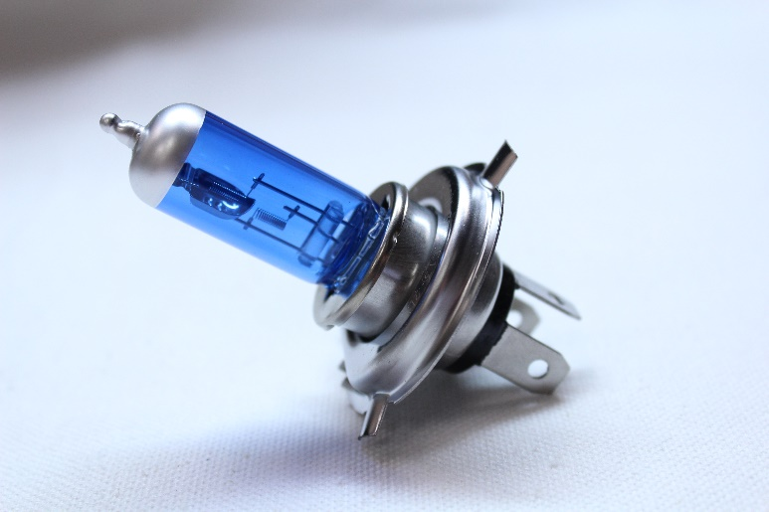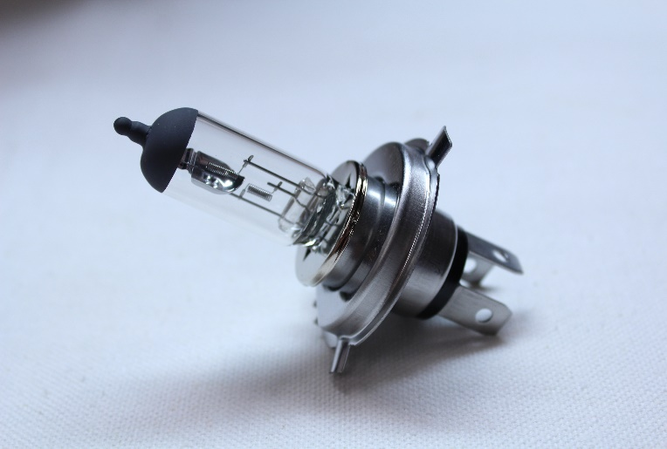

- The bulb is a common H4 lamp that can be purchased at any auto parts store. The bulb that was originally installed is a 55/60 H4 halogen lamp. Some bulbs are blue in color but illuminates a bright white color. You may also purchase a replacement bulb online or by calling us. If you have a blue tinted bulb you can order “Blue ultra-white H4 Halogen 55/60” BU-001. If you have a clear bulb you can order “Clear ultra-white H4 Halogen 55/60” BU-002.

- Remove any headlight bezels and retaining rings.

- Pull the headlight away from the car and disconnect the wire harness plug or our H4 Ceramic Harness to completely remove the headlight.

- USE EXTREME CAUTON; If the headlights have been on just prior to removing the headlight give the lamp/bulb time to completely cool. Some lamps can reach temperatures of up to 320 F degrees. Do not remove the bulb until at least an hour after being off to allow the bulb to completely cool.

- Looking at the back of the headlight remove the rubber boot to expose the retaining clip. Do not pull on the boot tab as it might break. Use you fingers and get under the edge of the boot and remove it. Push down on the retaining clip and push to one side to release the clip. Pull the clip away from the headlight. Now remove the lamp/bulb by pulling on the three prongs.

- Install the new lamp/bulb. If you are still not sure what to buy, take in your old bulb to the auto parts store and ask clerk to assist you. NEVER TOUCH THE NEW BULB AS FINGERPRINTS OR ANY RESIDUE CAN SHORTEN THE LIFE OF THE LAMP/BULB. If you touch the bulb clean it with denatured alcohol. Install new bulb. Push retaining clip back into place. Consult new lamp/bulb instructions for any care/installation instructions. Replace rubber boot.

- Reinstall the headlight back to your OEM Headlight harness or to our H4 Ceramic Harness connected to your OEM headlight harness.

- Replace headlight into light bucket. Reinstall headlight bezels and retaining rings but don’t over tighten screws. OVER TIGHTNING HEADLIGHT BEZELS OR RETAINING RINGS MAY CAUSE HEADLIGHT GLASS TO CRACK under some driving conditions. RedLine LumTronix INC is not responsible for any cracked glass after installment.

