Your Illusion ™ ; You Painting Your Halos To Match Your Vehicle
Instructions

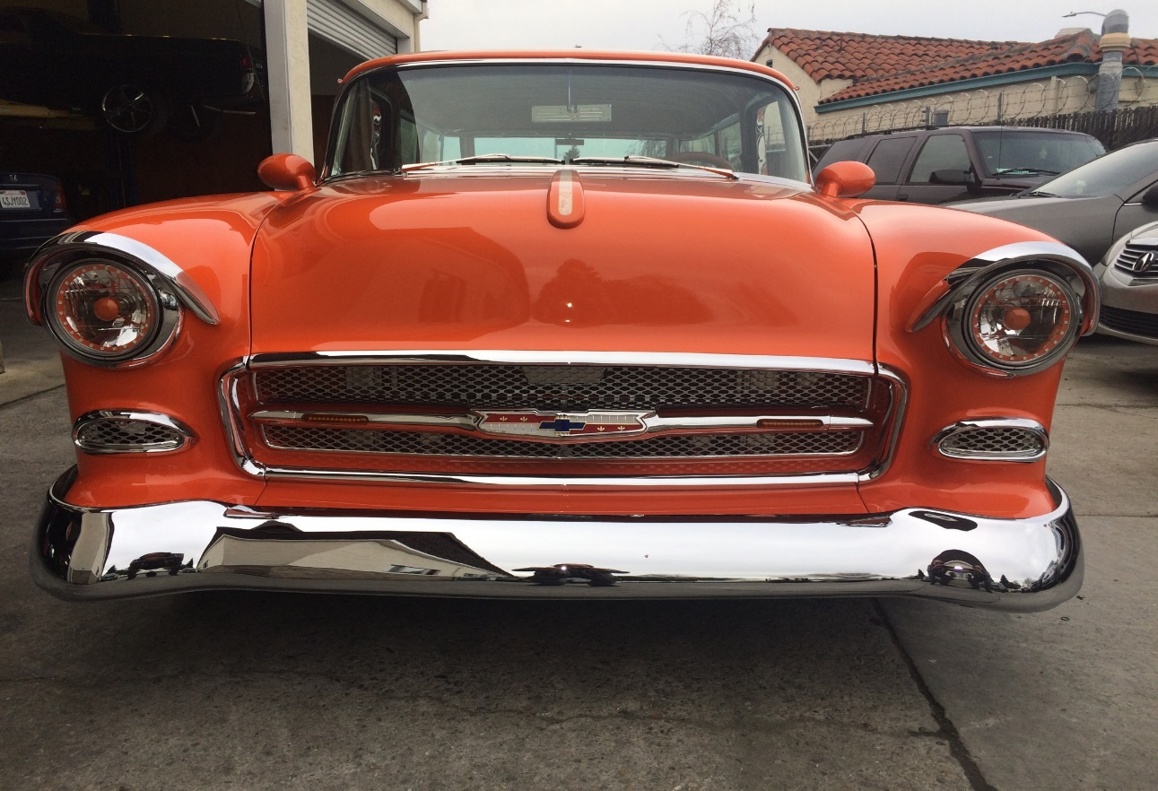

“Your Illusion” ™ headlights are headlights that reflect the painted choice of color of the vehicle owner to match or contrast the color of their vehicle. Once all the painted components (shield and halo) are installed into your headlights the illusion occurs when the color of choice is reflected on the reflector. Imagine your headlights blending with the same color of your car.

To create “Your Illusion” ™ halo headlights please follow the following steps.

You were sent halos and shields to match the number of headlights you have ordered. If you ordered one pair, you would have received 2 halos and 2 shields. If you ordered two pairs, you would have received 4 headlights and 4 shields. Included is an extra shield in case one of the others gets messed up.

You are to paint all the halos and shields sent to your color of choice

When painting the halos, you are to paint the front and back of the halo. Don’t worry about covering up each LED with paint as we scrape that paint off when we receive it. Please try to not get paint on any of the wires.

When painting the shields, paint the top and do not paint the inside of the shield, BUT you do need to paint both sides of the shield stems/legs.

Then mail back the halos and shields and when received we will make your “Your Illusion” ™ headlights.

If you have any questions, please give us a call at (855) 852-6435.

