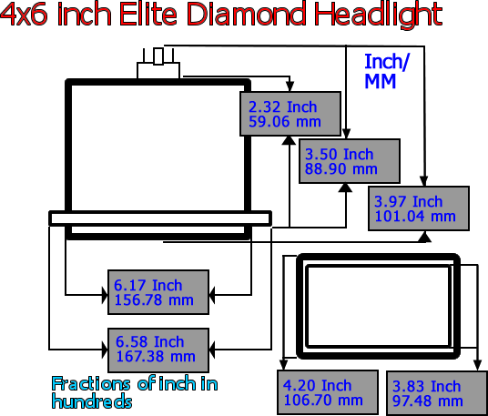

When taking a measurement of your headlight size use a tape measure and measure from top to bottom. If the measurement is over 4 inches, then the first setting of Height is 4 inches. Then take a measurement of your headlight size using a tape measure and measure from left to right. If the measurement is 6 inches or higher it is considered 6 inches. This is an industry standard sizing for use with these headlights.

