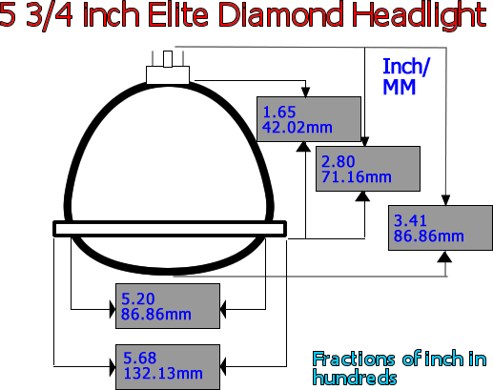
When taking a measurement of your headlight size use a tape measure and measure from top to bottom. If the measurement is close to 5 3/4 inches, then it is a 5 3/4 inch headlight.

