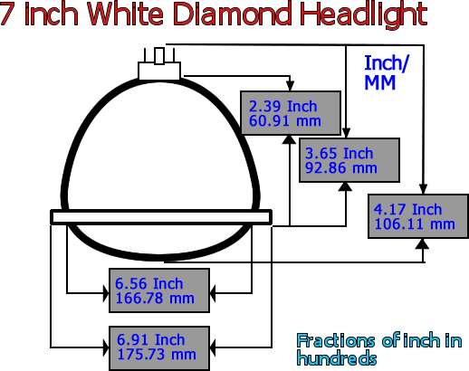

When taking a measurement of your headlight size use a tape measure and measure from top to bottom. If the measurement is close to 7 inches, then it is a 7 inch headlight.

