Installing LED bulb Instructions

This instruction set applies to the following NovaStar GT and GX models: 880, 881, H3, H8, H10, H11, H13, H16, HB1, HB4, HB5, 9004, 9005, 9006, 9007, 9008

Although installation instructions may be provided, it is essential that buyers understand RedLine LumTronix Inc vehicle lighting products are vehicle related and require installation and vehicle knowledge. Installation skill and experience varies so it is recommended the RedLine LumTronix Inc vehicle lighting products are installed professionally. RedLine LumTronix Inc are not responsible for any damage incurred by the improper installation of any products installed professionally or unprofessionally.

Always bench test this product before installation, so you may discover any problems before you spend the time to fully install this product.

Caution: Do not remove any bulb/lamp if it is hot as it may harm you.

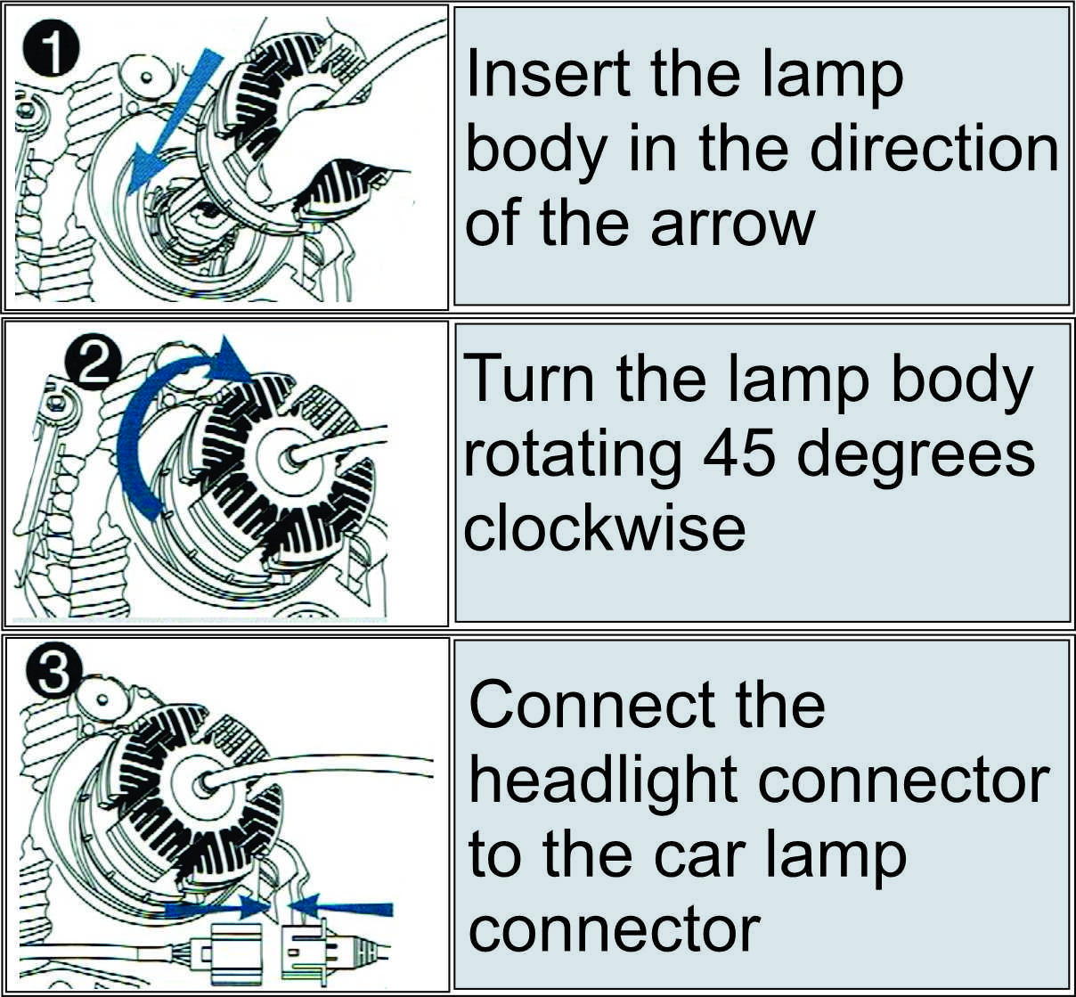

- Locate the bulb/lamp.

- Take notice on how the headlight connector is connected before you disconnect it as you want to make sure it is reconnected back the same way. Disconnect the headlight connector from the car lamp connector harness.

- Remove the bulb/lamp for the headlight housing unit rotating it 45 degrees counterclockwise to unlock the bulb.

- Figures 1 shows how to install the bulb/lamp into the headlight body in the direction of the arrow.

- Figures 2 shows that you then turn the bulb/lamp rotating it 45 degrees clockwise to lock the bulb in the proper place for focus.

- Figures 3 Connect the headlight connector to the car lamp connector.

