Safety First! These headlights not only look great, but provide greater visibility, typically 50% brighter than stock.
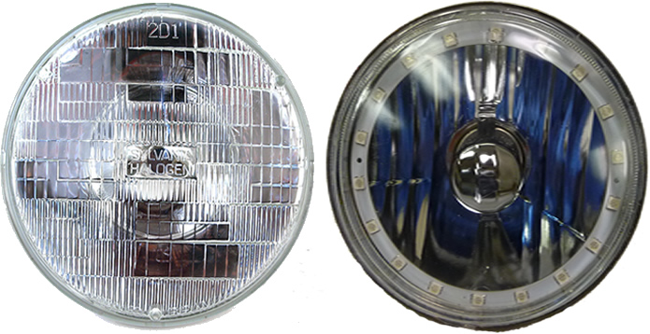
Notice the construction, in the sealed beam headlight on the left, you can see that all the focusing is done through prisms in the lens using a mirror on the back to reflect the light outward. The sealed beam design using prisms causes about 50 percent of the light to bounce back inward of the headlight causing you to not get the full effect of the light. In contrast we use a pattern on the backside of the headlight to focus the light through a clear lens thus reflecting more light.
In addition to a brighter light, the position of the halo provides more peripheral vision sidelight. Notice the side lens protruding from the headlight. Light is projected sideways from the headlight through this lens.
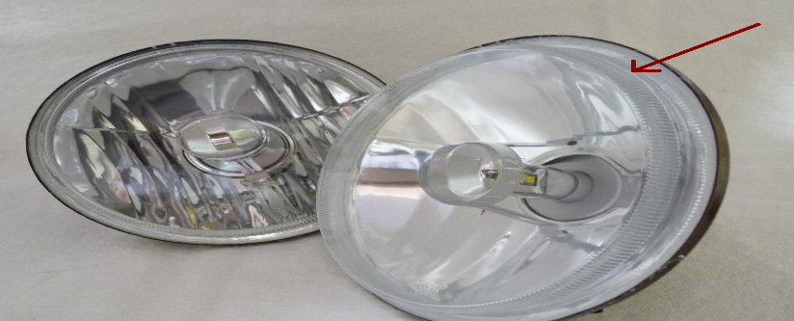

Installing the LED Ring to act like Daylight Running Light (DRL) lets other motorists see you more clearly in the daylight and before they pull out in front of you. Think about it right now if you’re traveling with your original sealed beams your actually running in the dark among all the new cars with Daylight Running Lights during the day time.

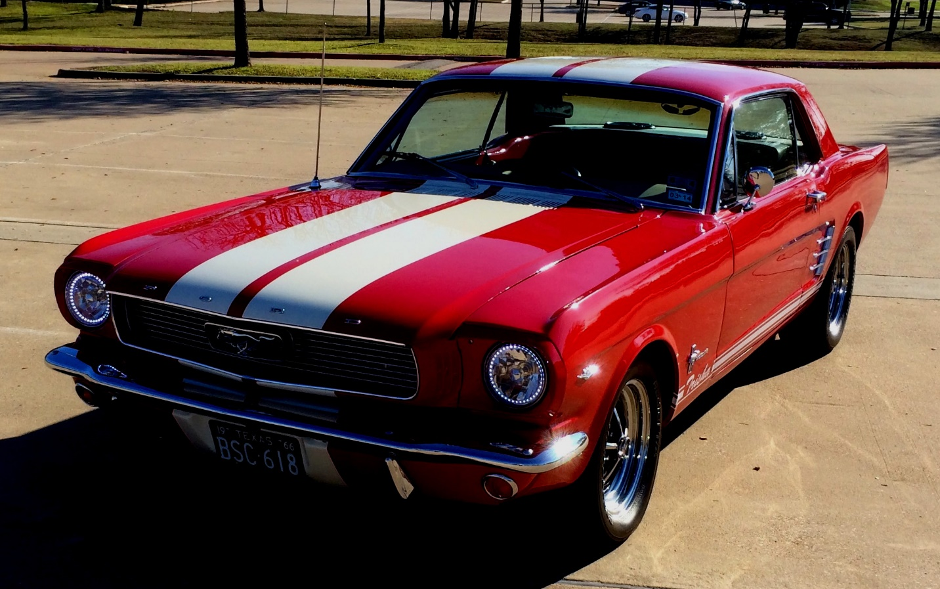

In addition to head-turning lighting technology, RedLine LumTronix built-in safety features will make you feel safer driving down the road, during the daytime or nighttime.

