Alternate Power Source Harness Installation Instruction (EH-006)

Although installation instructions may be provided, it is essential that buyers understand RedLine LumTronix Inc vehicle lighting products are vehicle related and require installation and vehicle knowledge. Installation skill and experience varies so it is recommended the RedLine LumTronix Inc vehicle lighting products are installed professionally. RedLine LumTronix Inc are not responsible for any damage incurred by the improper installation of any products installed professionally or unprofessionally.

Why do you need this: At cruise-in's many users like to show off their halos without leaving all your lighting on. This harness allows you to use truly little battery power. This harness has a three-way switch that allows you to switch to either ignition or battery power to power your halos.

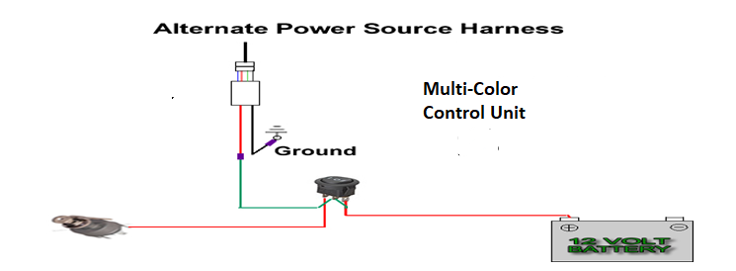
This is how you connect this harness to a Multi-Control Unit (CU-004)

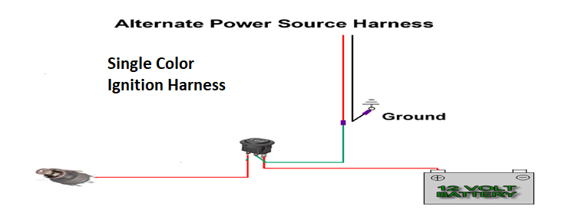
This is how you connect this harness to our Single Color Ignition Harness (EH-005)

Step 1. Connect the green wire on the center pole of the switch to the red wire of the multi color control unit or the single-color ignition harness.

Step 2. Connect the red wire with the hoop connector on the opposite end from the switch to your ignition.

Step 3. Connect the red wire with no connector to your battery or a battery source such as your internal clock.

Step 4. There are three positions on the switch left position is ignition; right position is battery and center is Off.

