Control Unit wire accessories Installation Instruction

Although installation instructions may be provided, it is essential that buyers understand RedLine LumTronix Inc vehicle lighting products are vehicle related and require installation and vehicle knowledge. Installation skill and experience varies so it is recommended the RedLine LumTronix Inc vehicle lighting products are installed professionally. RedLine LumTronix Inc are not responsible for any damage incurred by the improper installation of any products installed professionally or unprofessionally.

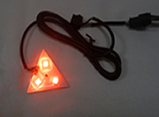 | 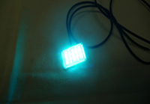
CU-001 | CL-002 | CG-001 | CG-002 | CE-001 | CE-002
 |  |  | 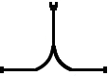 | 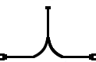
CE-004 | CE-006 | CE-008 | CY-001 | CY-002 | CY-004
LEDS-010 | LEDS-015 | LEDS-020 | LEDS-040 | LEDS-060 | LEDS-080

Always bench test any of these products before installation, so you may discover any problems before you spend the time to fully install any of these products.

All the above products have connectors on each. Those connectors are male and female and are interconnectable.

Although the LED Strips are waterproof the connector connection made between two components of a male and female connect is not. To make it waterproof use dielectric grease that you can purchase at any auto parts store and place it into the female connector and connect it to a male connector. This is only required if your any of the above products will be exposed to outside elements.

RedLine LumTronix Light ‘Em Up™ LED Strip with its many LED strip components allows you to place and extend a lighting system into any compartment of your vehicle. Think of Light ‘Em Up™ LED lighting system like the electrical system in your house.
Light 'Em up LED Strips and Components
Product Item # |  | Description | Unit Cost
CU-005 | 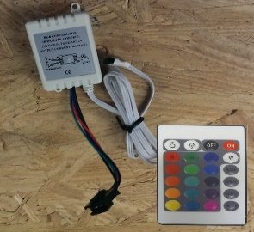 | Control Unit Infrared receiver with removable harness, Female connector, with Remote | $22.95
CU-001 | 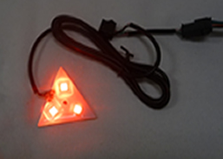 | In cab headlight color indicator (Each). This indicator will show you what color your LED's are set to outside. Multi-Color 3 SMD LED's M/F connector 36 inch wire extension | $14.95
CL-002 | 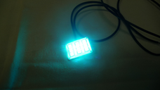 | Square LED light Multi-Color 9 SMD LED's M/F connector 36 inch wire extension | $18.95
CL-003 | 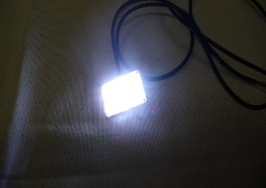 | Square LED light White 9 SMD LED's 36 inch positive and negative wire extension | $17.95
CG-001 |  | 1 foot Male to Male extention M/M connector | $3.95
CG-002 |  | 1 foot Female to Female extension F/F connector | $3.95
CE-001 |  | 1 foot Control Unit isolated wire extension M/F connector | $2.95
CE-002 |  | 2 foot Control Unit isolated wire extension M/F connector | $4.95
CE-004 |  | 4 foot Control Unit isolated wire extension M/F connector | $9.95
CE-006 |  | 6 foot Control Unit isolated wire extension M/F connector | $14.95
CE-008 |  | 8 foot Control Unit isolated wire extension M/F connector | $19.95
CY-001 |  | 2 Way "Y" Splitter F/M/M connector 1 foot wire extension | $4.95
CY-002 |  | 2 Way "Y" Splitter M/F/F connector 1 foot wire extension | $4.95
CY-003 | 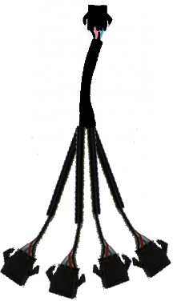 | 4 Way "Y" Splitter M/M/M/M/M connector 7 inch wire extension | $7.95
LEDS-010 |  | 1 Foot LED Strip Multi-Color 18 SMD LED's - 3M sticky base F/M connector | $11.17
LEDS-015 |  | 1.5 Foot Led Strip Multi-Color 27 SMD LED's - 3M sticky base F/M connector | $13.97
LEDS-020 |  | 2 Foot LED strip Multi-Color 36 SMD LED's - 3M sticky base F/M connector | $18.17
LEDS-040 |  | 4 Foot LED strip Multi-Color 72 SMD LED'S - 3M sticky base F/M connector | $32.17
LEDS-060 |  | 6 Foot LED Strip Multi-Color 108 SMD LED's - 3M sticky base F/M connector | $75.95
LEDS-080 |  | 8 foot LED Strip Multi-Color 144 SMD LED's - 3M sticky base F/M connector | $58.17
LEDS-016 |  | 16 foot LED Strip Multi-Color 288 SMD LED's - 3M sticky base F/M connector | $111.97
BASE-001 |  | 4 way Cable Mounting Base Black UV - 3M sticky base (Center hole for screw mount) | $0.12
TIE-001 |  | 4 inch Black UV ZIP Tie | $0.03
CON-001 | 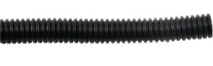 | 1/4 inch Black Split flexible conduit per foot | $0.25
SWH-001 | 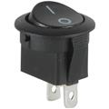 | Round on/off black Toggle switch | $4.05
SWH-002 | 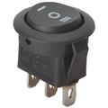 | Round on/off/on black Toggle center off switch | $4.55
FHD-005 | 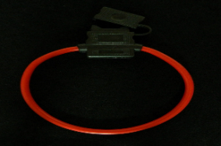 | Inline fuse holder with 5 amp fuse | $8.95
Prices are subject to change without prior notice. Please call us at (855) 852-6435 before ordering to verify current prices.

