Digital Flashers Installation Instruction (EF-002) (EF-003)

Although installation instructions may be provided, it is essential that buyers understand RedLine LumTronix Inc vehicle lighting products are vehicle related and require installation and vehicle knowledge. Installation skill and experience varies so it is recommended the RedLine LumTronix Inc vehicle lighting products are installed professionally. RedLine LumTronix Inc are not responsible for any damage incurred by the improper installation of any products installed professionally or unprofessionally.

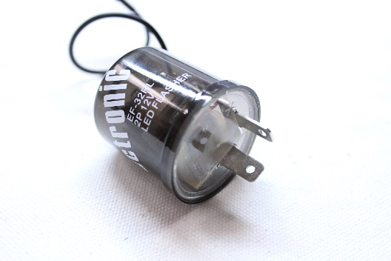 | 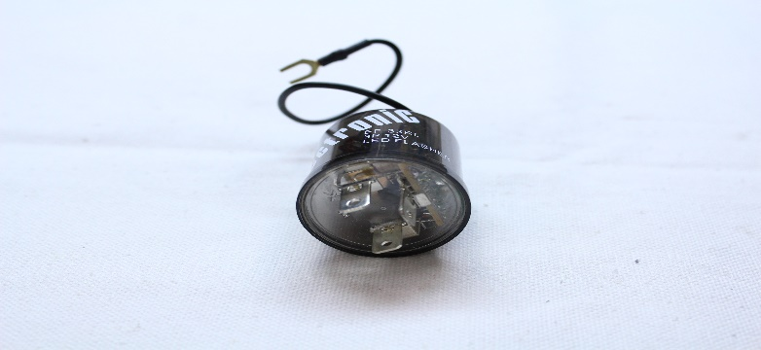
Two-prong Digital flasher (EH-002) | Three-prong Digital Flasher (EH-003)

Why do you need these: If you replace your turn signal incandesant bulbs with LED Bulbs, your old signal flashers will not work correctly! If you purchase our turn signal headlights or our turn signal LED bulbs you will need this digital flasher. Our digital flasher is unique to most digital flashers in the marketplace as it will work with both incandesant bulbs and LED Bulbs at the same time. So, if you have incandesant bulbs in the front of your vehicle and LED bulbs in the back our digital flasher will work with both as many other digital flashers will not work.

On vintage and classic vehicles, the flashers are usually found under the dash with the fuses. On more modern vehicles they may be found under the hood. If you cannot find the signal flasher, then check your vehicle user’s manual. You may also locate the signal flasher by putting on your turn signal while your vehicle is on and listen for the ticking sound. Vintage/classic OEM flashers are silver in appearance. There are usually two flashers one used for turn signals and the other used for a hazard signal. On vintage/classic vehicles you will need to replace both.

Step 1. Locate your turn signal flasher.

Step 2. Pull out the signal flasher straight out and look at the number of prongs at the bottom. If it has two prongs you will need to order our two-prong digital flasher (EH-002). If it has three prongs you will need to order our three-prong digital flasher (EH-002).

Step 3. Install your new digital flashers. Simply push the new flasher into place where you removed the old flasher. It should push in free and clear. If you have to force it in, something is wrong.

Step 4. Test the hazards and blinkers. With the vehicle in park, turn your key to accessory and test the turn signals. If they work and blink correctly, test the hazards.

