Installing H4 to H13 Ceramic Connector Wiring Harness (EH-004)
Installation Instruction

Although installation instructions may be provided, it is essential that buyers understand RedLine Lumtronix Inc vehicle lighting products are vehicle related and require installation and vehicle knowledge. Installation skill and experience varies so it is recommended the RedlLine LumTronix Inc vehicle lighting products are installed professionally. RedLine LumTronix Inc are not responsible for any damage incurred by the improper installation of any products installed professionally or unprofessionally.

Always bench test this product before installation, so you may discover any problems before you spend the time to fully install this product.

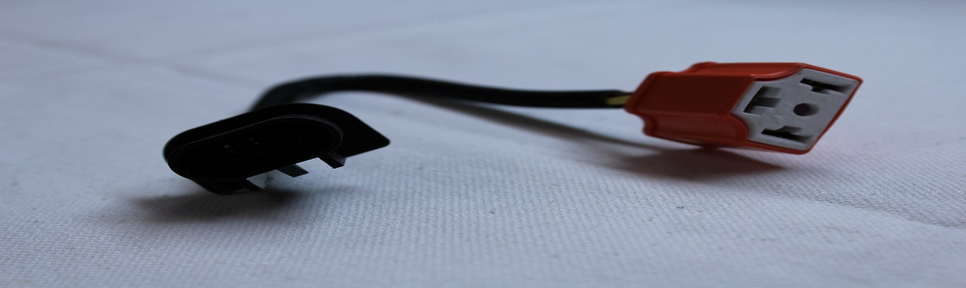

Purpose of this harness is to allow the installation from a H13 headlight harness to a H4 headlight:

- Connect the H4 ceramic tip connector of the harness to back of the three prongs of the headlight. NEVER leave a headlight hanging from the harness.

- Connect the H13 connector of the ceramic harness onto your vehicle harness headlight connector.

- Test.

