Installing LED bulb Instructions

This instruction set applies to the following NovaStar GT and GX models: H4, H7, HB2, 9003

Although installation instructions may be provided, it is essential that buyers understand RedLine LumTronix Inc vehicle lighting products are vehicle related and require installation and vehicle knowledge. Installation skill and experience varies so it is recommended the RedLine LumTronix Inc vehicle lighting products are installed professionally. RedLine LumTronix Inc are not responsible for any damage incurred by the improper installation of any products installed professionally or unprofessionally.

Always bench test this product before installation, so you may discover any problems before you spend the time to fully install this product.

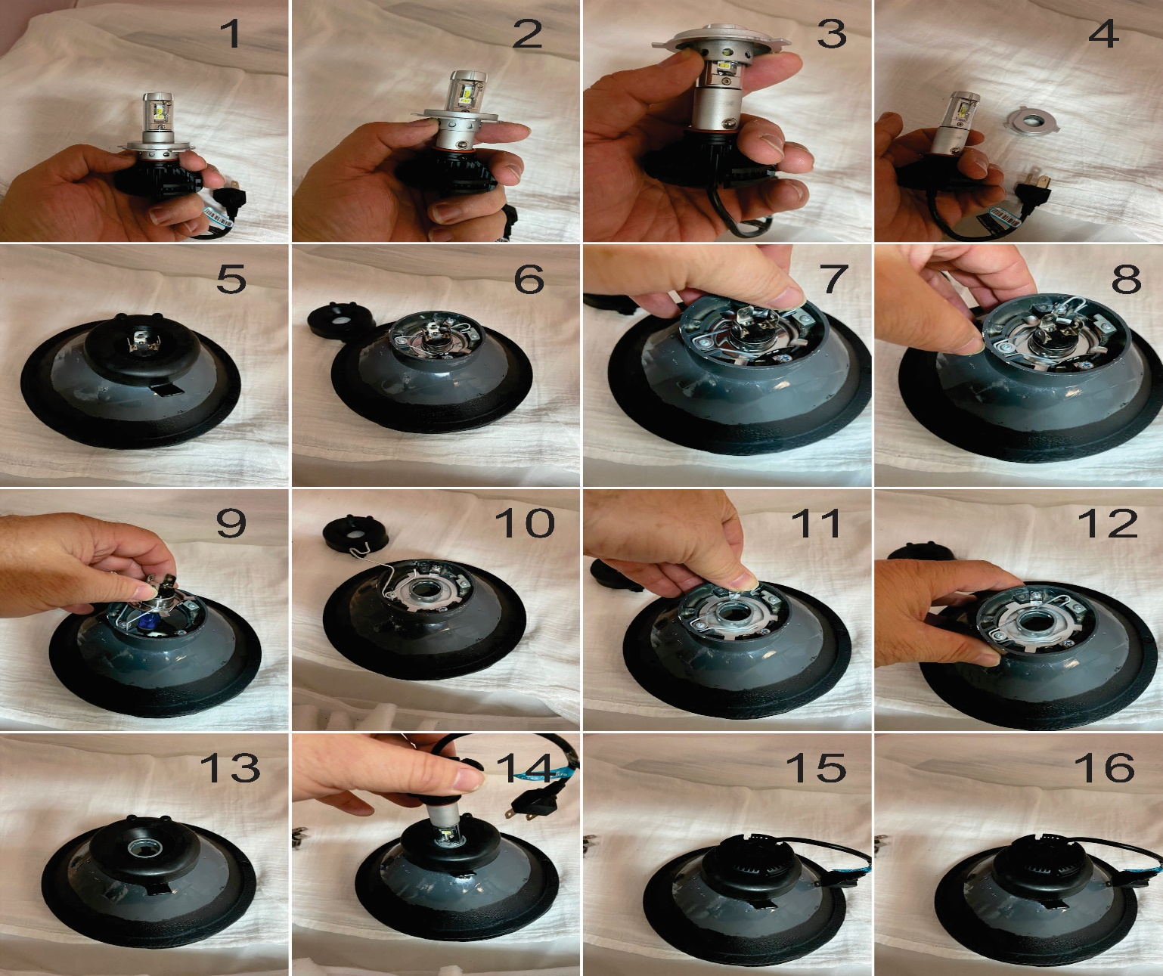
Caution: Do not remove any bulb/lamp if it is hot as it may harm you.

- Figures 1-4 shows the removal of the bulb collar. Push upward until the collar comes off the bulb.

- Figures 5-6 shows the removal of the boot. Never take the boot off with the tab, instead place your fingers under the edges of the boot along the neck of the headlight.

- Figures 7-9 shows the releasing of the bulb retainer spring and removal of the bulb. Remove the bulb by pulling upward while holding the three prongs until it is full removed from the headlight.

- Figure10-12 shows the insertion of the LED bulb collar you took off in step 1. Next reattach the bulb retainer spring.

- Figure 13 shows the installation of the boot over the neck of the headlight and the neck of the LED bulb collar.

- Figure 14-15 shows the installation of the LED Bulb. Just stick it in and the bulb is installed.

- Figure 16 is presented to let you know that you can rotate the LED Bulb by turning it clockwise or counterclockwise to get the desire light beam projection. We initially set the LED bulb position to be where the LED’s luminate the light from the center to the left and right into the headlight reflector.

