Installing a round 4 Headlight System Installation Instructions

Although installation instructions may be provided, it is essential that buyers understand RedLine LumTronix Inc vehicle lighting products are vehicle related and require installation and vehicle knowledge. Installation skill and experience varies so it is recommended the RedLine LumTronix Inc vehicle lighting products are installed professionally. RedLine LumTronix Inc are not responsible for any damage incurred by the improper installation of any products installed professionally or unprofessionally.

Vehicles with 4 round headlights; Each Headlight we sell is equipped with high and low beam bulb.

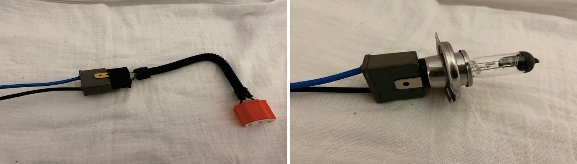

High Beam (Three prong Headlights) H5006

- Connect the ceramic tip of the harness to back of the three prongs of the headlight. Labeled as (EH-003) H5006 harness

- Connect the three male prongs of the ceramic harness onto your vehicle harness headlight connector.

Low Beam H5001

- Connect the ceramic tip of the harness to back of the three prongs of the headlight. Labeled as (EH-003) H4 harness

- Connect the three male prongs of the ceramic harness onto the two vertical prongs of your OEM vehicle harness headlight connector. The horizontal prong not connected is the low beam prong which will not have any power and will not cause you any problems. You can leave this unused prong, or you may bend or cut it off.

RedLine LumTronix INC is not responsible for and damage that may be caused to your OEM headlight harness if you decide to not use these harnesses.

