Light ‘Em Up™ LED Strip Installation Instruction

Although installation instructions may be provided, it is essential that buyers understand RedLine LumTronix Inc vehicle lighting products are vehicle related and require installation and vehicle knowledge. Installation skill and experience varies so it is recommended the RedLine LumTronix Inc vehicle lighting products are installed professionally. RedLine LumTronix Inc are not responsible for any damage incurred by the improper installation of any products installed professionally or unprofessionally.

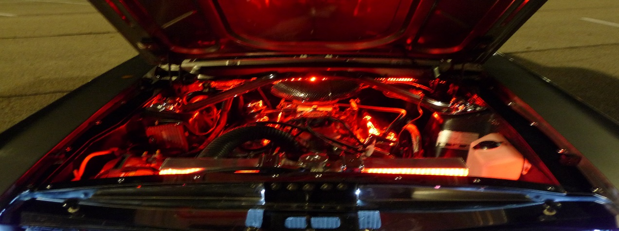

Features
- Environmentally friendly and power saving.  - Strips are silicone encased IP67 waterproof.  - Input Voltage: 12v - 24v.  - Long life: 50,000 hours or more.  - Wattage: 55 Watts.  - Durable and non-fading brilliant beams.  - Instantly and immediately light up.  - Plug-n-Play, means simple installation. | - Stick-n-Stay made with 3M Red VHB adhesive glue.  - No slicing, dicing, soldering of wires or crimping of pins.  - Includes one Male and female connector.  - Works with all RedLine LumTronix multi-color controllers.  - Compatible with and can be connected to all RedLine LumTronix Multi-color products.  - Good vibration resistance and stable emitting.

Installation Do’s and Don’ts

Do’s:
• The LED strips are attached to your vehicle with adhesive tape. It is imperative that the mounting surface be clean and free of wax, oil, or grease. It is best to clean the area with “Oil and Wax” remover (found at an automotive store) before applying any mounting base or LED strips. Only attach LED strips after running all support wiring to where the LED strips will finally be placed.
• Try to run LED extension wires away from heat as much as possible.
• Always secure your wires with cable mounting bases and ties.
• Only cut LED strips according to Light ‘EM Up LED Strips Cutting Instructions attached.
• ALWAYS USE AN INLINE FUSE WITH A 5 AMP FUSE OR LESS
• Always connect the Negative wire first.
• Bundle excess LED wire and secure it to mounting bases with zip ties.
• Never combine kits and use only one control unit as it might not provide the necessary power required.
• Although the LED Strip is waterproof the connector connection made between two components of a male and female connect is not. To make it waterproof use dielectric grease that you can purchase at any auto parts store and place it into the female connector and connect it to a male connector. This is only required if your LED Strip will be exposed to outside elements.

Don’ts:
• Never mount LED strips to extremely hot surfaces such as exhaust pipes and engine cylinder heads.
• Never leave your wire hanging anywhere.
• Take caution when connecting your controller to your vehicle battery.
• Be careful not to make sharp bends in LED Strip. Avoid sharp bends where the wire connects to the strip as it can cause the connection to short out over time.

Installation Instructions
Steps | Description
1 | TEST EVERYTHING BEFORE INSTALLATION; Take all items out of the box and inventory quantity against Item List. Then connect all items loosely (don’t install yet) according to layout diagram in Figure 1. Attach the black wire of the Control Unit to a negative 12 volt battery and the red wire of the Control Unit to a positive on the battery to make sure all the LED’s light up and correctly show colors selected from the remote. Call us immediately if anything does not work.
2 | Clean all surfaces that you will stick mounting bases and LED strip adhesive back with “Oil and Wax” remover. “Oil and Wax” can be purchased from any automotive store.
3 | Lay out all items to where they are to be placed. Never stick adhesive items first! Install from the Control unit first, attaching all items into your desired configuration. That way if you need additional items you can measure and determine what you need. Go to Step 8 for information about additional items.
4 | Install the Control Unit in the cab and position the Infrared receiver in a place where you can point the remote at for changing colors. Infrared receiver placement outside the cab is ok as it is water resistant. The red wire will need to be attached to the positive side of a 12 volt battery source. The black wire of the Control Unit is to be grounded to a chassis or the negative side of a 12 volt battery source.  Note: The control unit is not waterproof, so if you decide to install it outside the cab you will need to waterproof it in some way.
5 | Connect all items listed into your desired configuration
6 | Evenly install mounting bases. Mounting bases maybe also screwed into place through the center hole or stuck to the surface via the adhesive base.
7 | Use the wire ties to secure the conduit to the cable mounting base.
8 | If you fail to have enough length in extension wires or need other accessories, please check the attached LED Strip Component List for purchase of additional items.

Light ‘EM Up ™ LED Strips Cutting Instructions

Regardless of the length of the “Light 'EM Up LED Strip,” the sizing and cutting instructions are the same.

“Light 'EM Up LED Strips” can be cut EVERY THIRD LED; counting the LED's from either end where the wire connectors connect to the light strip. If you have no need for one of the end extension wires you may cut that too.

Use a SHARP pair of wire cutters or scissors and cut in the center line as seen below between the bulbs as shown below. If you don’t cut exactly in the center line all LED’s before the cut will not function properly.

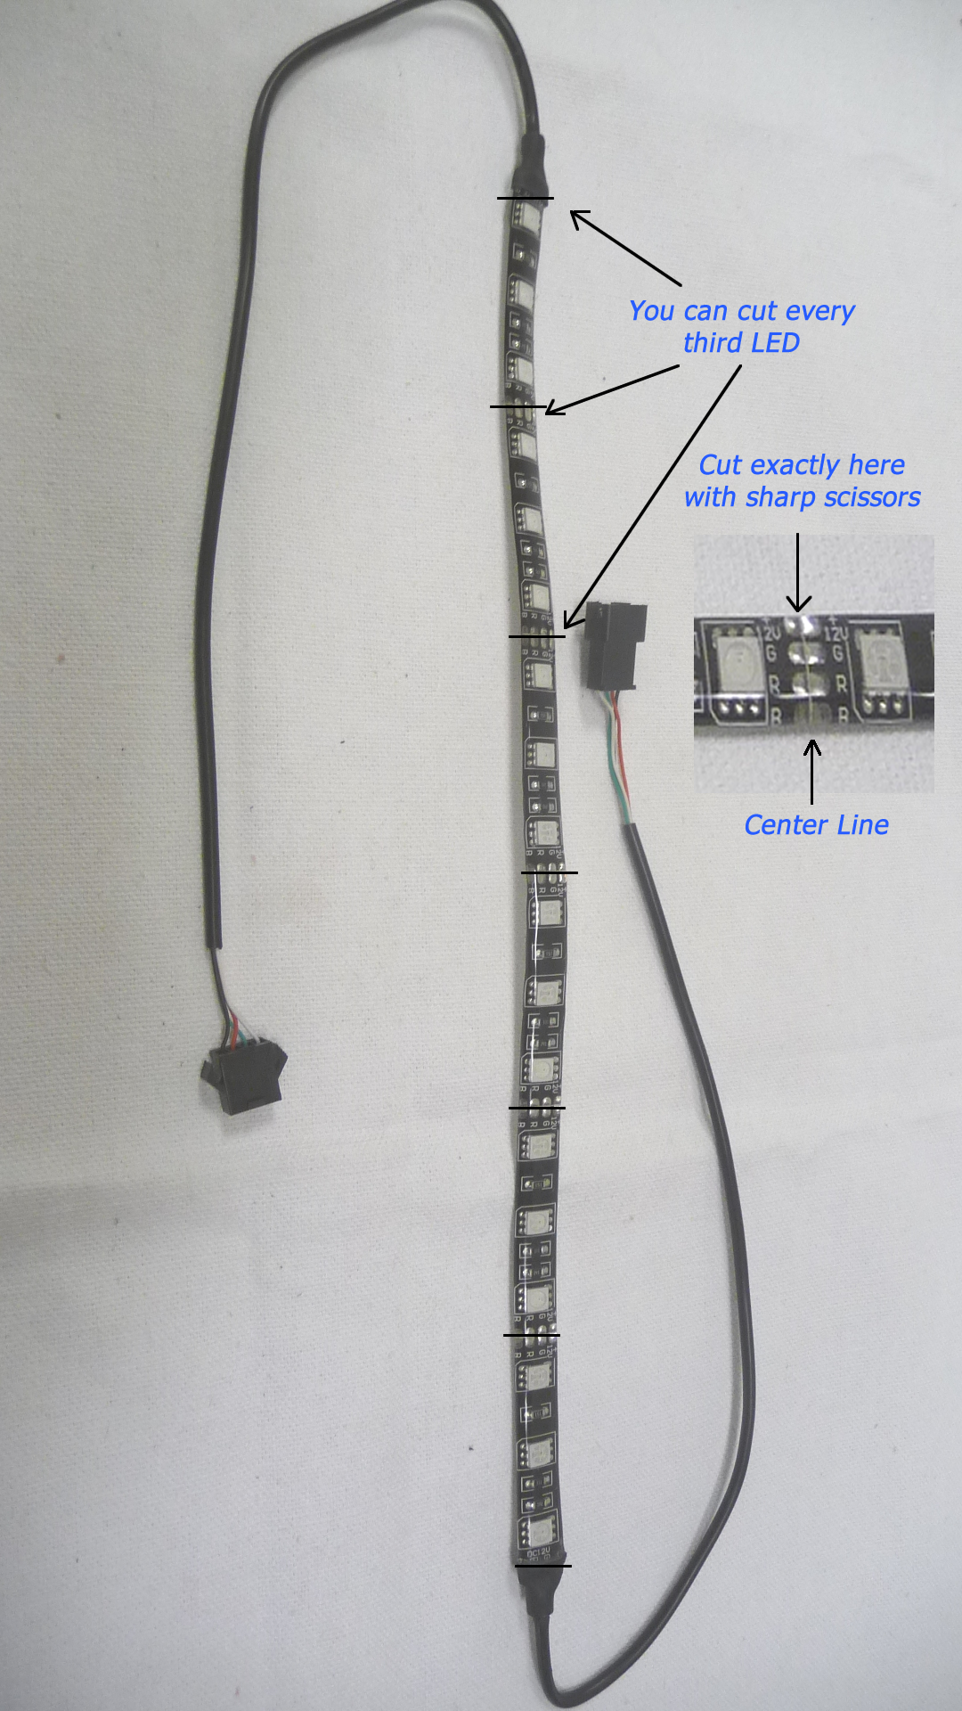

Light 'Em up LED Strips and Components
Product Item # |  | Description | Unit Cost
CU-005 | 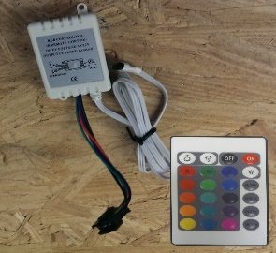 | Control Unit Infrared receiver with removable harness, Female connector, with Remote | $22.95
CU-001 | 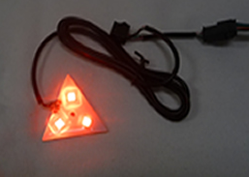 | In cab headlight color indicator (Each). This indicator will show you what color your LED's are set to outside. Multi-Color 3 SMD LED's M/F connector 36 inch wire extension | $14.95
CL-002 | 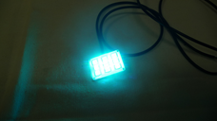 | Square LED light Multi-Color 9 SMD LED's M/F connector 36 inch wire extension | $18.95
CL-003 | 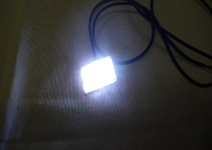 | Square LED light White 9 SMD LED's 36 inch positive and negative wire extension | $17.95
CG-001 |  | 1 foot Male to Male extention M/M connector | $3.95
CG-002 |  | 1 foot Female to Female extension F/F connector | $3.95
CE-001 |  | 1 foot Control Unit isolated wire extension M/F connector | $2.95
CE-002 |  | 2 foot Control Unit isolated wire extension M/F connector | $4.95
CE-004 |  | 4 foot Control Unit isolated wire extension M/F connector | $9.95
CE-006 |  | 6 foot Control Unit isolated wire extension M/F connector | $14.95
CE-008 |  | 8 foot Control Unit isolated wire extension M/F connector | $19.95
CY-001 | 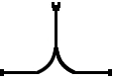 | 2 Way "Y" Splitter F/M/M connector 1 foot wire extension | $4.95
CY-002 | 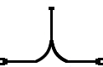 | 2 Way "Y" Splitter M/F/F connector 1 foot wire extension | $4.95
CY-003 | 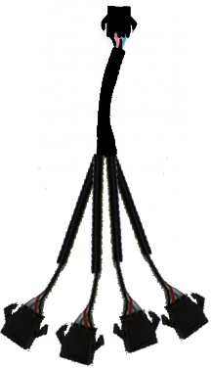 | 4 Way "Y" Splitter M/M/M/M/M connector 7 inch wire extension | $7.95
LEDS-010 |  | 1 Foot LED Strip Multi-Color 18 SMD LED's - 3M sticky base F/M connector | $11.17
LEDS-015 |  | 1.5 Foot Led Strip Multi-Color 27 SMD LED's - 3M sticky base F/M connector | $13.97
LEDS-020 |  | 2 Foot LED strip Multi-Color 36 SMD LED's - 3M sticky base F/M connector | $18.17
LEDS-040 |  | 4 Foot LED strip Multi-Color 72 SMD LED'S - 3M sticky base F/M connector | $32.17
LEDS-060 |  | 6 Foot LED Strip Multi-Color 108 SMD LED's - 3M sticky base F/M connector | $75.95
LEDS-080 |  | 8 foot LED Strip Multi-Color 144 SMD LED's - 3M sticky base F/M connector | $58.17
LEDS-016 |  | 16 foot LED Strip Multi-Color 288 SMD LED's - 3M sticky base F/M connector | $111.97
BASE-001 |  | 4 way Cable Mounting Base Black UV - 3M sticky base (Center hole for screw mount) | $0.12
TIE-001 |  | 4 inch Black UV ZIP Tie | $0.03
CON-001 | 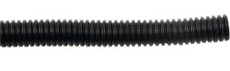 | 1/4 inch Black Split flexible conduit per foot | $0.25
SWH-001 | 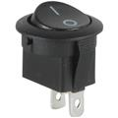 | Round on/off black Toggle switch | $4.05
SWH-002 | 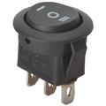 | Round on/off/on black Toggle center off switch | $4.55
FHD-005 | 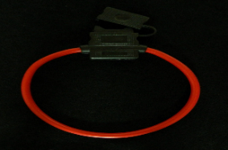 | Inline fuse holder with 5 amp fuse | $8.95
Prices are subject to change without prior notice. Please call us at (855) 852-6435 before ordering to verify current prices.

