Multi-Color Remote Instructions

Although installation instructions may be provided, it is essential that buyers understand RedLine LumTronix Inc vehicle lighting products are vehicle related and require installation and vehicle knowledge. Installation skill and experience varies so it is recommended the RedLine LumTronix Inc vehicle lighting products are installed professionally. RedLine LumTronix Inc are not responsible for any damage incurred by the improper installation of any products installed professionally or unprofessionally.

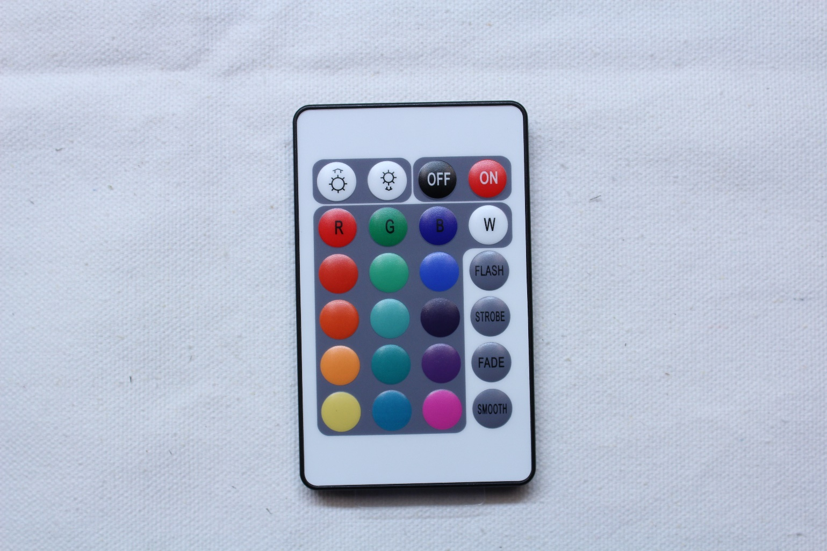

Top right two buttons: Are the ON allowing you to power up the control unit to show colors. The OFF button turns off the control unit turning off everything.

Top left two buttons: Allow you to change the intensity of the color. The left button allows you to dial up the intensity of the color making it brighter. The right button allows you to dial down the intensity of the color making it dimmer.

Second row buttons: Allow you to select the basic colors of Red, Green, Blue, White.

Third to Sixth row of colored buttons: Are colors you can select.

Last column of buttons below the White color button are modes. You have the following modes: Flash, Strobe, Fade, Smooth. For the most part these modes are what they say they are. Each mode provides the effect while going through several colors. The best way to experience what they do is for you to try them. While in a mode select an intensity button to change the effects.

