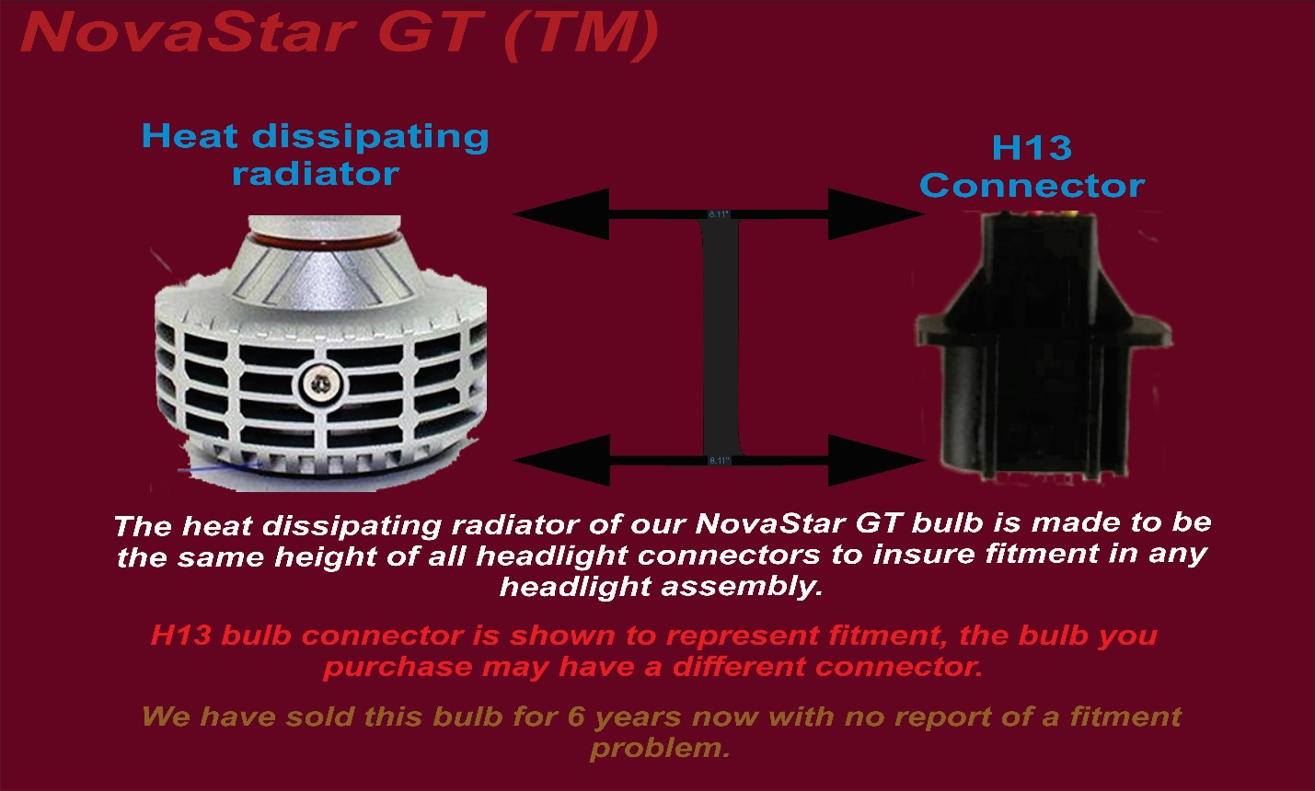

This fitment information applies to NovaStar GT ™ LED Headlight bulb for Models: H1, H3, H8, H9, H10, H11, H13, H16, HB1, HB4, HB5, 880, 881, 9004, 9005, 9006, 9007, 9008

