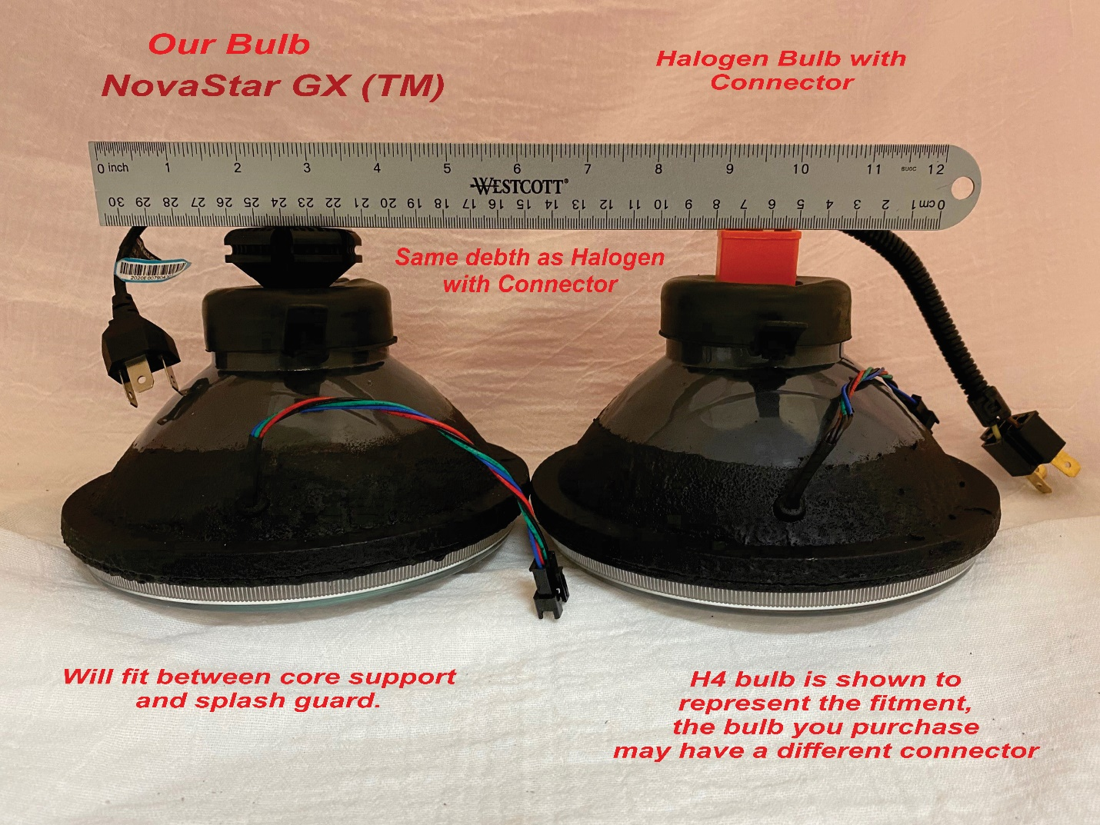

This fitment information applies to NovaStar GX ™ LED Headlight bulb for Models: H1, H4, H7, HB2, 9003.

