Safety First! Why LED headlight bulbs? Brighter is safer. Here is the fact... LED Lighting has become more prevalent all around us. Street lighting, automotive lighting, and signage lighting are all brighter now.

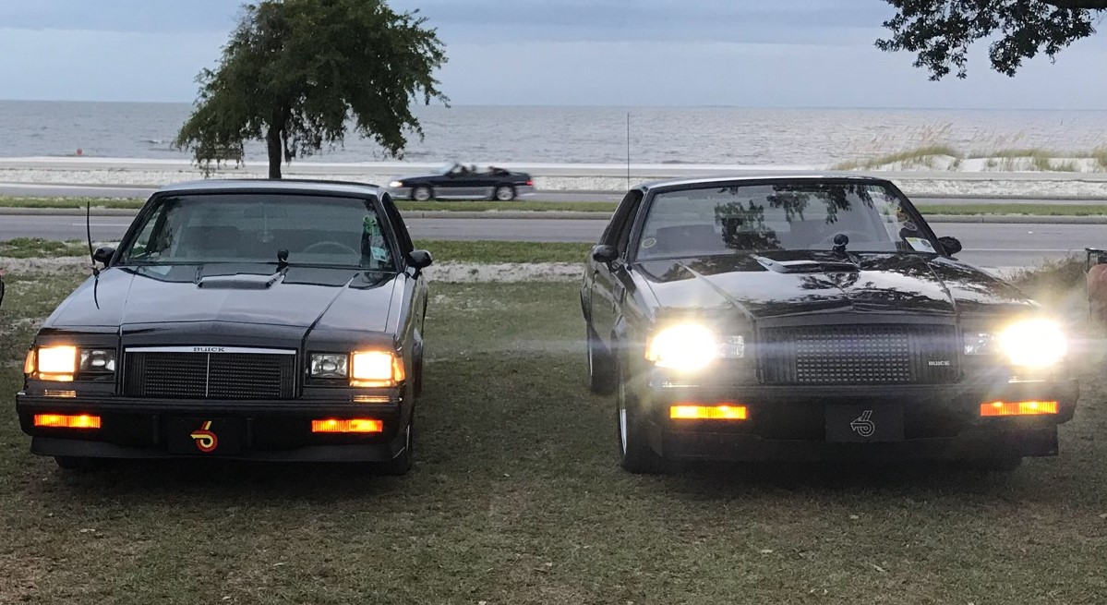

The days of the incandescent light (a bulb with a filament) are over. LED lighting is immediately noticeable due to its brightness. Incandescent lighting puts out a yellowish light whereas LED bulbs put out a bright white with a slight blue tint.
For the last six to eight years, automotive manufacturers have only installed LED lighting. The next time you are traveling down a highway look at the cars on the other side of the road coming toward you. You will easily notice the cars with incandescent lighting versus LED lighting. You may be at the number of cars that have LED lighting. You may be surprised at the number of cars that have LED lighting. Pictured above are two Buick Grand Nations that demonstrate the difference. On the left is an incandescent sealed beam headlight with yellowish lighting. On the right is our LED headlight bulb in a pair of our headlights with bright white lighting. Notice how much brighter, so much so that you can’t even see that the car has 4 headlights. Incandescent sealed beams are 300 lumens per headlight. Our NovaStar GT and GX ™ models are 3000 lumens per headlight. Wow, that is 10x brighter than sealed beams. 3000 lumens are the highest number of lumens to be DOT legal.

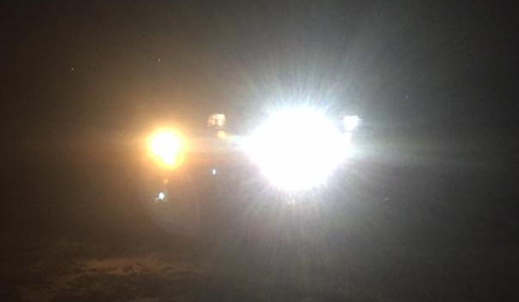
Incandescent bulb versus our NovaStar GX LED Headlight bulb in the same vehicle.
Why do you need LED headlight bulbs? Picture yourself in your vintage/classic vehicle at night, dusk, or in a rainstorm. Imagine a 2021 Ford F150 truck with each headlight illuminating at 3000 lumens coming toward you. If you are looking into lights rapidly approaching you, your eyes dilate and adjust to the lighting. Once the truck passes, it will seem like you have no light in front of your vehicle. So, do you need LED lighting? Definitely! Many of the cars coming toward you will have LED lighting and you do not want to come up short by not seeing the road.
If you are like most vintage/classic owners you have spent a lot of money on your vehicle, so why not purchase our NovaStar GT/GX headlight bulbs and make your vehicle safe. Safety First!

We also carry the following LED headlight replacement bulbs for new vehicles and vintage/classic vehicles:
H1,H3,H4,H7,H8,H9,H10,H11,H13,H16,HB1,HB2,HB3,HB4,HB5,880,881, 9003,9004,9005,9006,9007,9008

