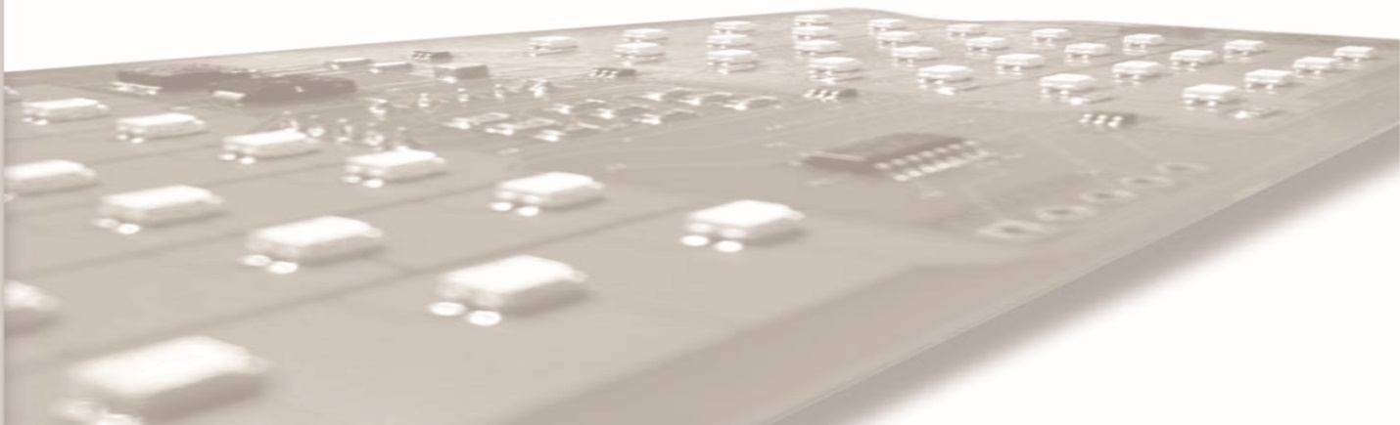

Fitment

No worry about fitment as your taillight fitment is based on your year, make and model.

All Digi-Tails taillights and parking lights products are not bulbs, but panels filled with LEDs made to precisely fit between your existing tail lens and taillight housing. Digi-Tails products do not include either a tail lens or taillight housing. Each kit also contains all the hardware to mount the taillight panels to the lens or the taillight housing.

Further explanation of how to install Digi-Tails taillights and parking lights are found in their installation guides. Wiring is always color coded to be the same as the Original Equipment Manufacturer (OEM) wiring harness making it extremely easy to install.

