Safety is always First! When engineering all our products including all our accessories, we insure you that they are made to the highest standards and are safe, and quality made. All our LED Bulbs are far brighter than their Original Equipment Manufacturer (OEM) incandescent equivalents. Brighter bulbs mean you can see better, and everyone will see you.

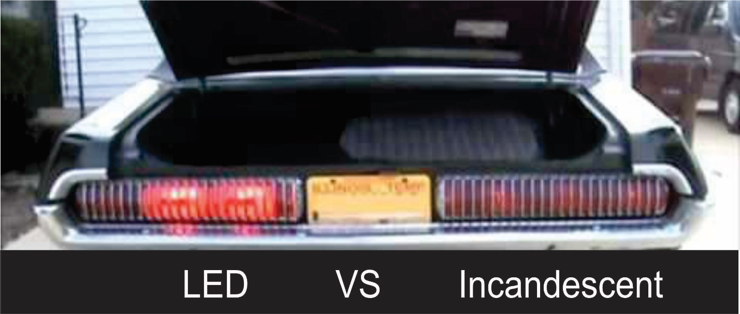

This is a safety issue, the cougar above with LED bulbs on the left and Incandescent bulbs on the right. You can barely see the Incandescent bulbs. If I were the owner of this Cougar, I would prefer to be seen especially if I had to stop quickly.

The days of the incandescent light (a bulb with a filament) are over. LED lighting is immediately noticeable due to its brightness. Incandescent lighting puts out a yellowish light whereas LED bulbs put out a bright white with a slight blue tint.
If you are like most vintage/classic owners you have spent a lot of money on your vehicle, so why not purchase our LED bulbs and make your vehicle safe. Safety First!

