Safety is always First! When Digi-Tails engineered all their products they made their taillight to the highest standards of safety and quality with an added factor of WOW! Original Equipment Manufacturer (OEM) taillights are especially dim in our new everything is LED world. Sequential taillights are the next evolution in taillights. Digi-Tail taillights are not bulbs but instead a panel full of LED blasting light out of every inch available in the tail lens. Imagine how bright! Their taillights are far brighter than their Original Equipment Manufacturer (OEM) incandescent equivalents. Brighter taillights mean everyone can see you better, so your safer.

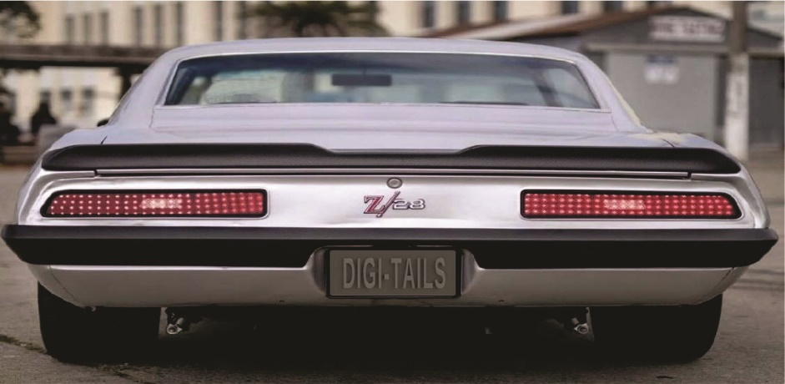

This is a safety issue, if you were the owner of this Camaro Z/28, wouldn’t you prefer to be seen especially if I had to stop quickly?
The days of the incandescent light (a bulb with a filament) are over. LED lighting is immediately noticeable due to its brightness. Incandescent tail lighting puts out a dull light whereas LED taillight panels put out a blast of light to be seen by all.
If your like most vintage/classic owners you have spent a lot of money on your vehicle, so why not make a safety purchase for Digi-Tail taillight and make your vehicle safer.
There is nothing like DIGI-TAILS on the street, making DIGI-TAILS one of your most satisfying upgrades ever.

Safety First!

